- Find the average salary of employees in each department.
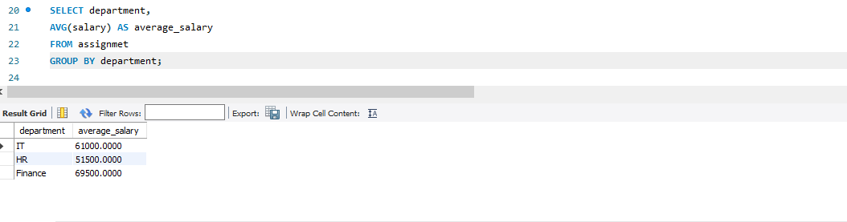
- Find the total number of employees hired after 2019.
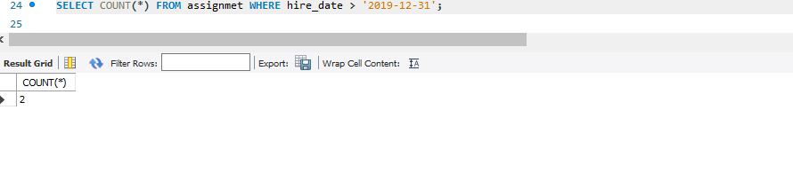3.List the departments and the total salary of all employees in each department, ordered by the total salary.
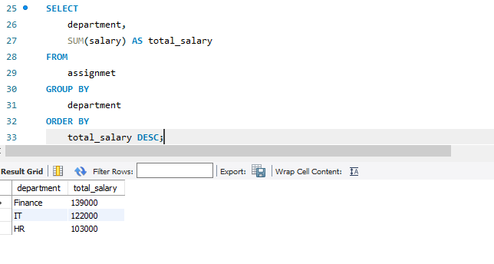 4.Find the highest salary in the Finance department.
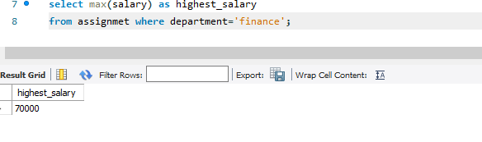
5. Get the top 3 highest-paid employees.
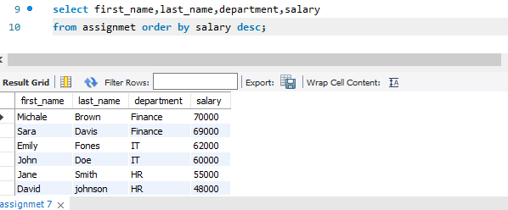
6. Find the department with the minimum average salary.
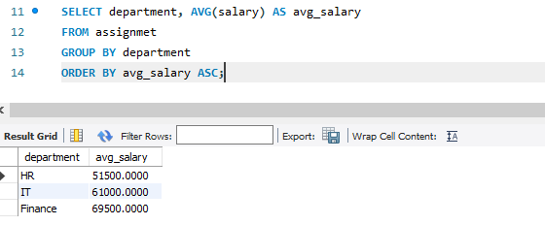
7. Display the total number of employees in each department, ordered by the number of employees.
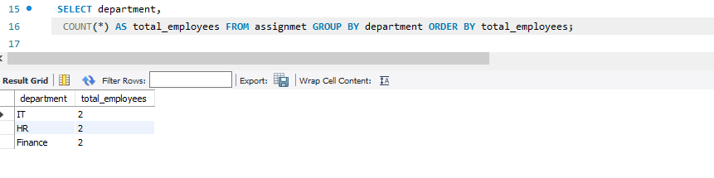
8. Find the average salary of employees who were hired before 2020.
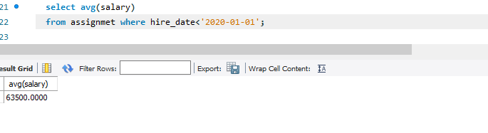
9. List the names of employees in the IT department ordered by hire date, with the most recently hired employees first.
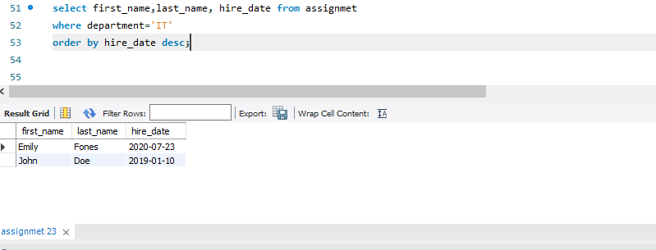
10. Find the sum of salaries for all employees hired after January 1, 2019, ordered by salary.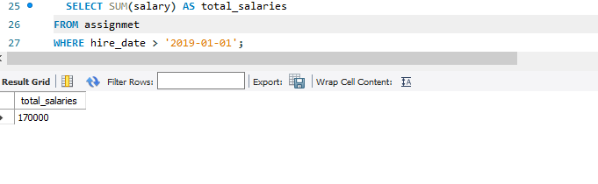
11. Get the employee with the lowest salary in the HR department.
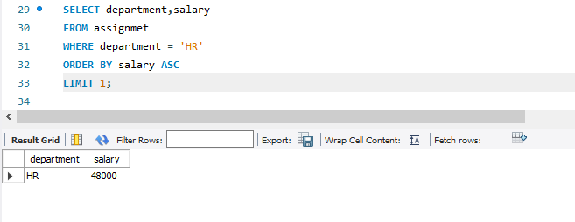
12. Find the total salary paid to employees in each department, but limit the result to the top 2 highest-paying departments.
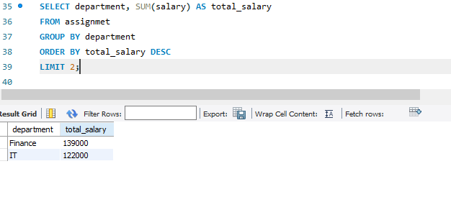
13. List all employees hired after 2018, ordered by salary, and show only the first 4 employees.
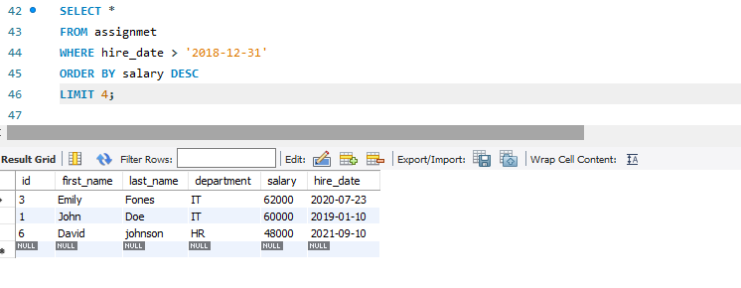
14. Find the highest salary in the IT department, but limit the results to the top 1 result.
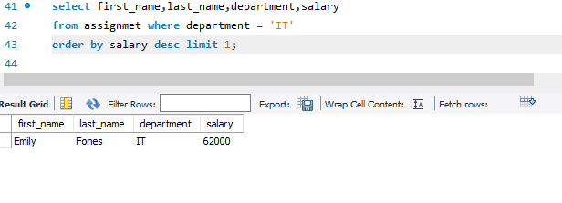
15. Get the average salary of employees in each department and list only departments with an average salary greater than $60,000.



